India fights Corona Covid-19

Coronavirus disease (COVID-19) pandemic 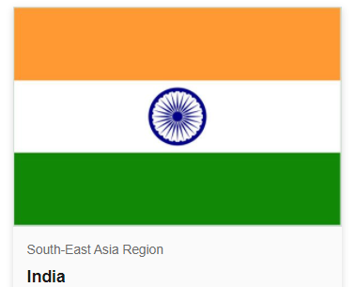

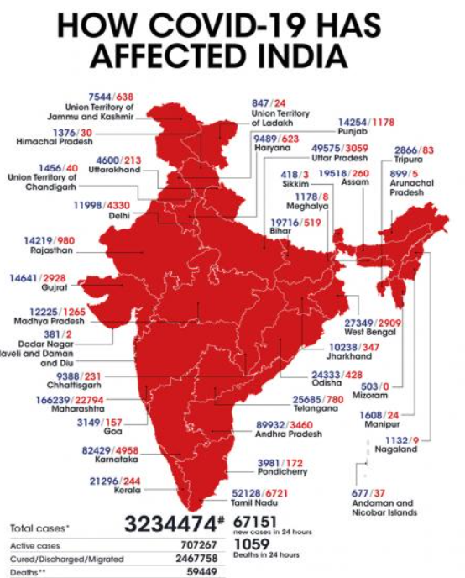 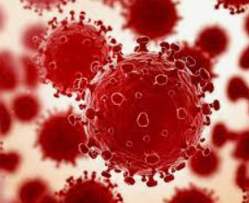

Now that COVID-19 vaccines have reached billions of people worldwide, the evidence is overwhelming that no matter which one you take, the vaccines offer life-saving protection against a disease that has killed millions. The pandemic is far from over, and they are our best bet of staying safe

Coronavirus disease (COVID-19) is an infectious disease caused by the SARS-CoV-2 virus. Government of India is taking all necessary steps to ensure that we are prepared well to face the challenge and threat posed by the growing pandemic of COVID-19 the Corona Virus. Purpose of this project to represent the state wise data of num of cases of corona, deaths, cured , vaccinated & how Corona has impacted the life .And the majors taken to get people vaccinated

**Below are the Top 10 States with highest number of Confirmed cases**

|  |  |
| --- | --- |
| **Top 10 States with highest number of Confirmed cases** | **Sum of Confirmed** |
| Andhra Pradesh | 374631235 |
| Chhattisgarh | 154749830 |
| Delhi | 274298085 |
| Karnataka | 462620921 |
| Kerala | 427313974 |
| Maharashtra | 1070657336 |
| Rajasthan | 153785608 |
| Tamil Nadu | 408786439 |
| Uttar Pradesh | 297247727 |
| West Bengal | 249317376 |
| **Grand Total** | **3873408531** |

|  |  |
| --- | --- |
| **!0 Bottom Staes with lowest confirmed Cases** | **Sum of Confirmed** |
| Andaman and Nicobar Islands | 1870612 |
| Arunachal Pradesh | 6730183 |
| Cases being reassigned to states | 345565 |
| Dadra and Nagar Haveli and Daman and Diu | 1863487 |
| Ladakh | 3870882 |
| Lakshadweep | 823634 |
| Mizoram | 2594668 |
| Nagaland | 4785970 |
| Sikkim | 2938742 |
| Unassigned | 161 |
| **Grand Total** | **25823904** |

**Top/bottom 10 states with highest number of Cured cases**

|  |  |
| --- | --- |
| **States** | **10 Highest cured States** |
| Andhra Pradesh | 352926995 |
| Chhattisgarh | 142720847 |
| Delhi | 260720476 |
| Karnataka | 418977225 |
| Kerala | 390311164 |
| Maharashtra | 969585013 |
| Odisha | 142222495 |
| Tamil Nadu | 381444416 |
| Uttar Pradesh | 276311742 |
| West Bengal | 233983721 |
| **Grand Total** | **3569204094** |

|  |  |
| --- | --- |
| **Row Labels** | **10 Lowest Cured** |
| Andaman and Nicobar Islands | 1781610 |
| Cases being reassigned to states | 0 |
| Dadra and Nagar Haveli and Daman and Diu | 1766366 |
| Ladakh | 3578014 |
| Lakshadweep | 729839 |
| Meghalaya | 5983682 |
| Mizoram | 2109700 |
| Nagaland | 4281131 |
| Sikkim | 2530368 |
| Unassigned | 0 |
| **Grand Total** | **22760710** |

**Top/bottom 10 states with highest number of Deaths**

|  |  |  |  |
| --- | --- | --- | --- |
| **10 states** | **highest number of Deaths** | **10 States** | **Sum Lowest of Deaths** |
| Andhra Pradesh | 2817970 | Andaman and Nicobar Islands | 25975 |
| Chhattisgarh | 1942099 | Arunachal Pradesh | 24646 |
| Delhi | 4717732 | Cases being reassigned to states | 0 |
| Gujarat | 2128759 | Dadra and Nagar Haveli and Daman and Diu | 986 |
| Karnataka | 5759340 | Ladakh | 43941 |
| Maharashtra | 22665169 | Lakshadweep | 3457 |
| Punjab | 2638818 | Mizoram | 8331 |
| Tamil Nadu | 5608369 | Nagaland | 53229 |
| Uttar Pradesh | 3938519 | Sikkim | 49983 |
| West Bengal | 3683145 | Unassigned | 0 |
| **Grand Total** | **55899920** | **Grand Total** | **210548** |

**Top/bottom 10 states with highest of Death percentage**

|  |  |
| --- | --- |
| **Row Labels** | **Sum of Deaths** |
| Unassigned | 0.00% |
| Cases being reassigned to states | 0.00% |
| Dadra and Nagar Haveli and Daman and Diu | 0.47% |
| Lakshadweep | 1.64% |
| Mizoram | 3.96% |
| Arunachal Pradesh | 11.71% |
| Andaman and Nicobar Islands | 12.34% |
| Ladakh | 20.87% |
| Sikkim | 23.74% |
| Nagaland | 25.28% |
| **Grand Total** | **100.00%** |

|  |  |
| --- | --- |
| **Row Labels** | **Sum of Deaths** |
| Maharashtra | 40.55% |
| Karnataka | 10.30% |
| Tamil Nadu | 10.03% |
| Delhi | 8.44% |
| Uttar Pradesh | 7.05% |
| West Bengal | 6.59% |
| Andhra Pradesh | 5.04% |
| Punjab | 4.72% |
| Gujarat | 3.81% |
| Chhattisgarh | 3.47% |
| **Grand Total** | **100.00%** |

**Top/bottom 10 states with highest number of Total Samples**

|  |  |
| --- | --- |
| **States** | **Sum of highest TotalSamples** |
| Uttar Pradesh | 9155561731 |
| Bihar | 6121329928 |
| Maharashtra | 5703822545 |
| Karnataka | 5453628818 |
| Tamil Nadu | 5436042291 |
| Andhra Pradesh | 4127211823 |
| Gujarat | 3745364851 |
| Delhi | 3499131565 |
| Kerala | 3350897050 |
| Telangana | 2680729201 |
| **Grand Total** | **49273719803** |

|  |  |
| --- | --- |
| **States** | **Sum of lowestTotalSamples** |
| Dadra and Nagar Haveli and Daman and Diu | 6324267 |
| Lakshadweep | 12622334 |
| Sikkim | 23149220 |
| Ladakh | 27988511 |
| Nagaland | 42911316 |
| Mizoram | 64100385 |
| Andaman and Nicobar Islands | 72336655 |
| Chandigarh | 79203122 |
| Meghalaya | 96858864 |
| Arunachal Pradesh | 132259016 |
| **Grand Total** | **557753690** |

**Top/bottom 10 states with highest number of Negative cases**

**Top/bottom 10 states with highest number of Positive cases**

|  |  |
| --- | --- |
| **Row Labels** | **Sum of Negative** |
| Manipur |  |
| Mizoram | 0 |
| Lakshadweep |  |
| West Bengal | 568 |
| Andaman and Nicobar Islands | 1210 |
| Bihar | 2299 |
| Odisha | 64160 |
| Nagaland | 109169 |
| Goa | 115631 |
| Sikkim | 438779 |
| **Grand Total** | **731816** |

|  |  |
| --- | --- |
| **Row Labels** | **Sum of Negative** |
| Andhra Pradesh | 3325546267 |
| Jharkhand | 1593489409 |
| Jammu and Kashmir | 1591716108 |
| Madhya Pradesh | 1211881437 |
| Uttarakhand | 715848996 |
| Haryana | 712426421 |
| Rajasthan | 535500271 |
| Maharashtra | 383680847 |
| Himachal Pradesh | 306291739 |
| Tripura | 183907117 |
| **Grand Total** | **10560288612** |

|  |  |
| --- | --- |
| **Row Labels** | **Sum of Positive** |
| Maharashtra | 96901583 |
| Kerala | 79723175 |
| Jharkhand | 46499325 |
| Tamil Nadu | 12772604 |
| Tripura | 10061637 |
| Gujarat | 8009517 |
| Delhi | 6848173 |
| Puducherry | 6287323 |
| Karnataka | 4701197 |
| Andhra Pradesh | 3859260 |
| **Grand Total** | **275663794** |

|  |  |
| --- | --- |
| **Row Labels** | **Sum of Positive** |
| Lakshadweep |  |
| Sikkim | 17644 |
| Mizoram | 19785 |
| Meghalaya | 33904 |
| Arunachal Pradesh | 51245 |
| Chandigarh | 59195 |
| Ladakh | 89027 |
| Nagaland | 90682 |
| Manipur | 101501 |
| Himachal Pradesh | 119494 |
| **Grand Total** | **582477** |

**Male and Female Vaccinated ratio for Covid19**

|  |  |  |  |
| --- | --- | --- | --- |
| **Total Num of Male Vaccinated** | **Total Num of Female Vaccinated** |  | **Ratio** |
| 18579894484 | 16340809968 |  | 1 1/7 |

**Covaxin and Covishield Vaccination**

|  |  |  |
| --- | --- | --- |
| **Total Covaxin Administered** | **Total CoviShield Administered** | **Ratio** |
| 4408372879 | 36316339316 | 1/8 |

**Doses administered vs People Vaccinated**

|  |  |  |
| --- | --- | --- |
| **Total Doses Administered** | **Total Individuals Vaccinated** | **Ratio** |
| 40814304071 | 33503614338 | 1 2/9 |

**ANALYSIS OF DATA PRESENTS STATS AS BELOW**

* Maharashtra has & had the highest count of Confirmed cases & Lakshadweep with lowest confirmed cases .
* Maharashtra has & had the highest count of cured & positive cases & Lakshadweep with lowest cured & positive cases confirmed cases .
* Maharashtra has the highest death cases & Dadra and Nagar Haveli and Daman and Diu with lowest Death cases .
* Uttar Pradesh has the highest total sample & Dadra and Nagar Haveli and Daman and Diu with the lowest
* Andhra Pradesh has the highest Nagative cases & Mizoram,Maniour with Lowest
* Ratio of Male vs Female vaccinated is 11/7
* Ratio of Covaxin and Covishield Vaccination 1/8
* Ratio of Doses administered vs People Vaccinated 12/9